PERSONAL HYGIENE HABITS :
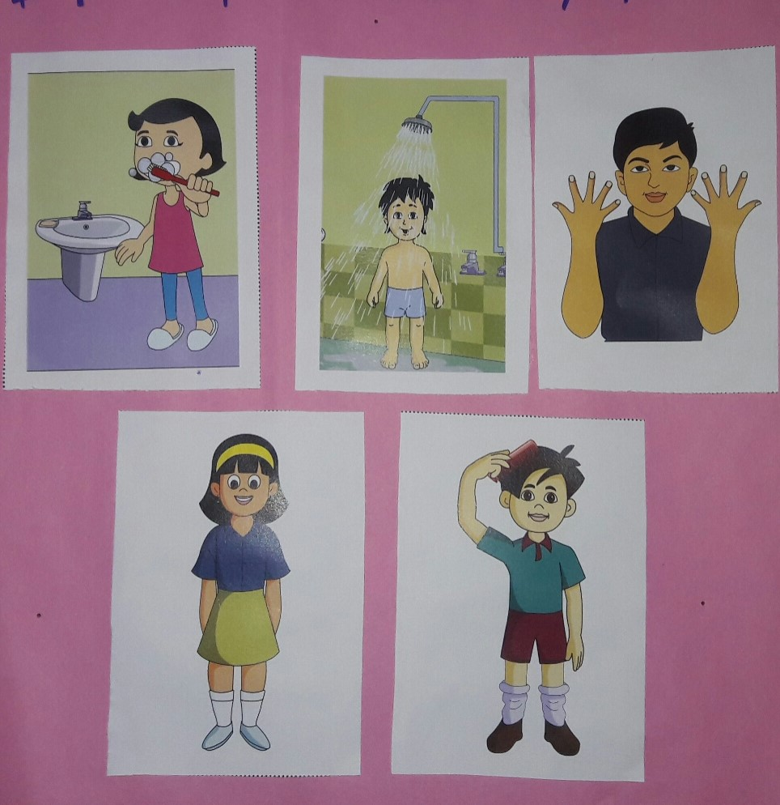
- A CHILD BRUSHING TEETH.
- A CHILD BATHING.
- A CHILD HAVING CUT AND CLEAN NAILS.
- A CHILD WEARING CLEAN CLOTHES.
- A CHILD COMBING HAIR.

